

VILNIUS UNIVERSITY
ŠIAULIAI ACADEMY
BACHELOR PROGRAMME SOFTWARE ENGINEERING

Service-oriented Architecture
Lab work No. 2

Group members: Hanna Asiadouskaya
Leacture: Vaidas Giedrimas

Šiauliai, 2024

Get all employees
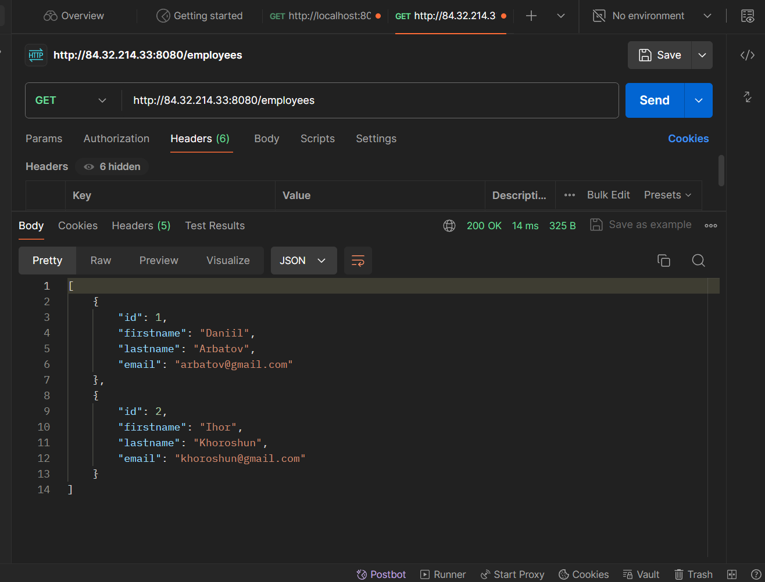
Get employee by ID
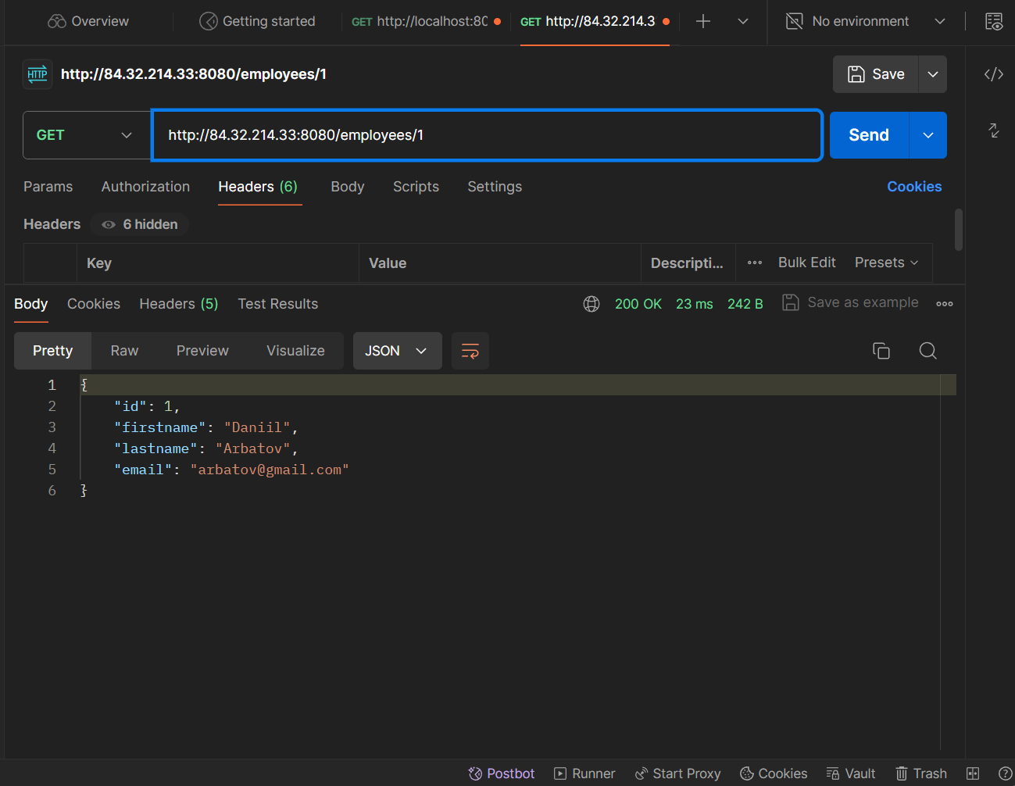

Controller
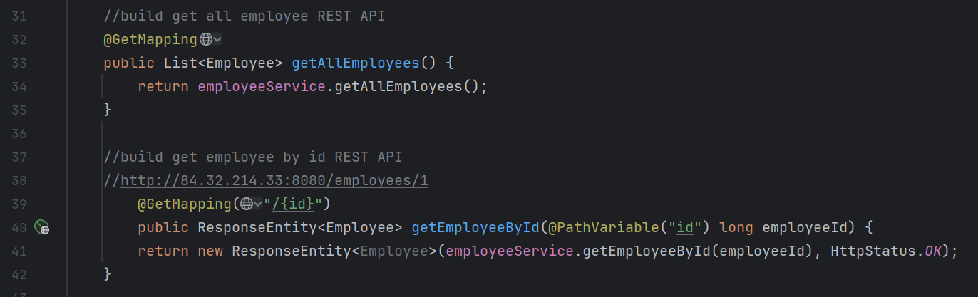
Implementation
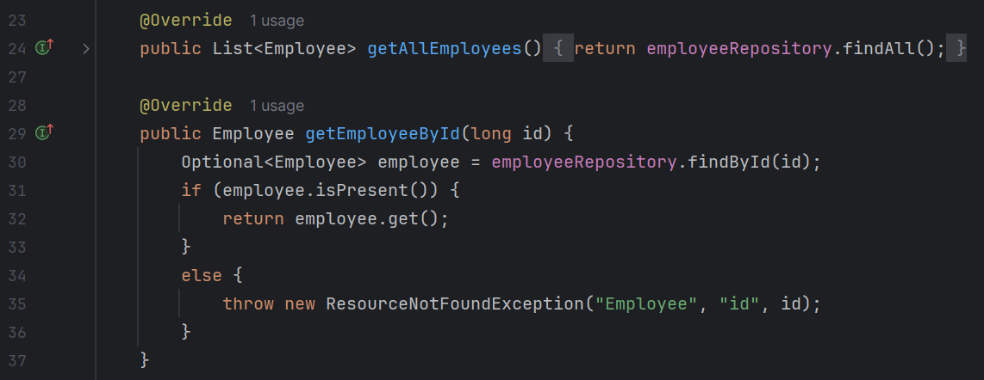
Entity Class
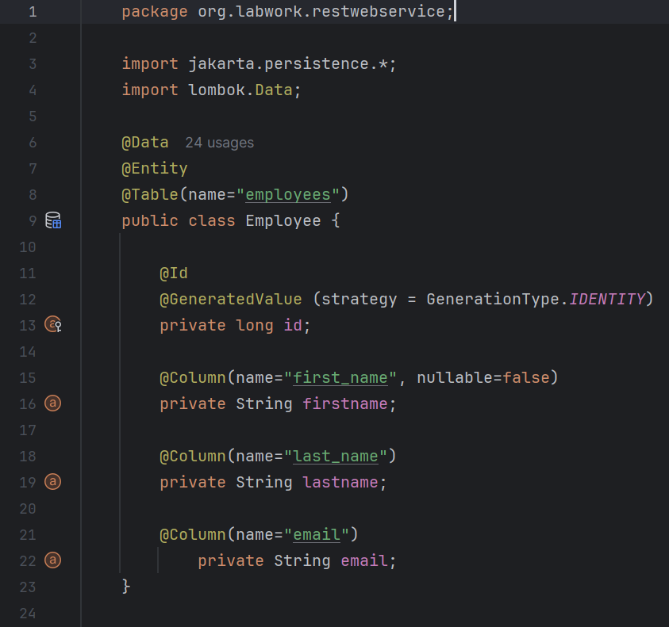
Connection to the DB:

